**Lab Report No : 02**

**Lab Report Name : Basic Command of Linux Operating System**

**Question : What is Linux command?**

**Answer :**Linux is a Unix-Like operating system. All the Linux/Unix commands are run in the terminal provided by the Linux system. This terminal is just like command prompt of Windows OS. Linux/Unix commands are case-sensitive. The terminal can be used to accomplish all Administrative tasks. This includes package installation, file manipulation, and user management. Linux terminal is user-interactive. The terminal outputs the results of commands which are specified by the user itself.

**Question: Describe the operation of Linux basic command(screenshot).**

**Answer :**The operation of basic Linux command is given below :

1. ls : ls command is used for listing contents of a directory. It works as dir command.

Example :

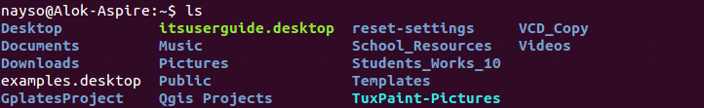

1. pwd :pwd command displays the name of current/working directory as below.

Example :



1. chmod: chmod command is used to change/update file access permissions like this .

Example:

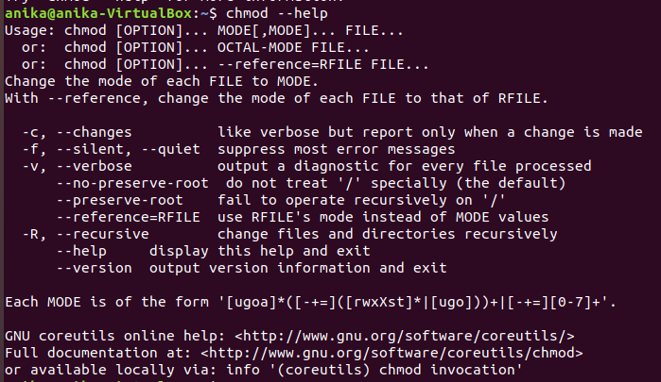

1. df: df command is used to show file system disk space usage as follows.

Example :

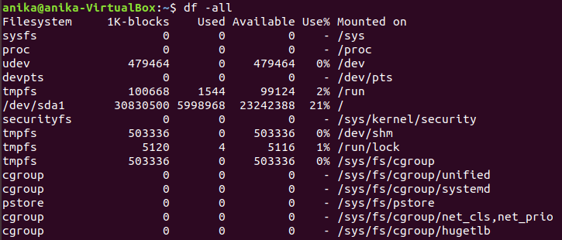

1. du: du command is used to show disk space usage of files present in a directory as well as its sub – directories .

Example :

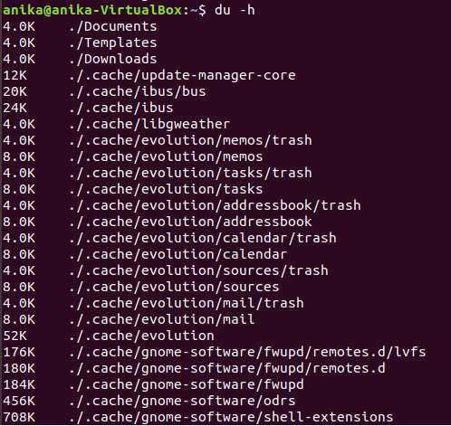

1. mkdir :mkdir command is used to create single or more directories, if they do not already exist (this can be overridden with the –p option).

Example :

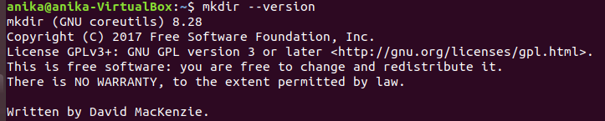

1. passwd :passwd command is used to create or update passwords for user accounts, it can also change the account or associated password validity period.

Example :

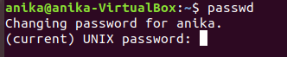

1. rm :rm command is used to remove files or directories .

Example :

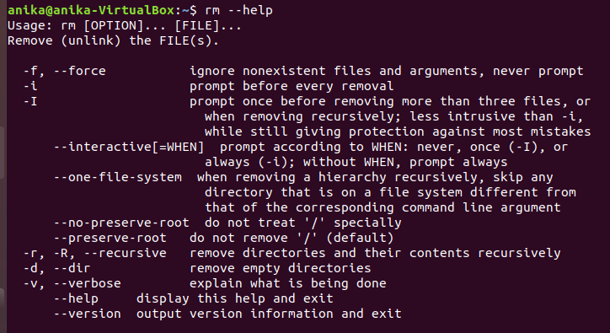

1. ln : ln command is used to create a soft link between files using the –s flag .

Example :

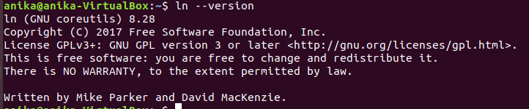

1. tar : tar command is a most powerful utility for archiving files in Linux.

Example :

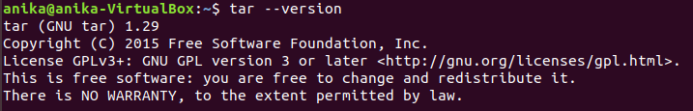

1. cd : cd stands for change directory and it does the same as it name stands for.

Example :

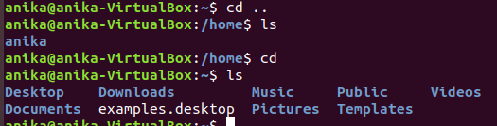

1. bzip2 : bzip2 command is used to compress or decompress files.

Example :

